7.7 Smooth Muscle

STOVE

* **Multiunit** (like motor unit, neurogenic) vs **single-unit** (functional syncytium, myogenic)
* 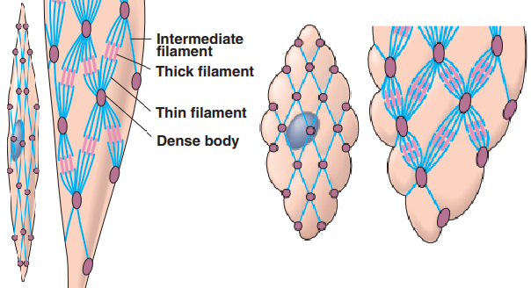Structure difference: small and **NOT striated** (not straight filaments, no sarcomere)
  + **Dense body**: anchors for thin and thick, anchored by intermediate filaments
* Ca activates myosin light chains for cross bridge activation (phosphorylation of myosin)
  + 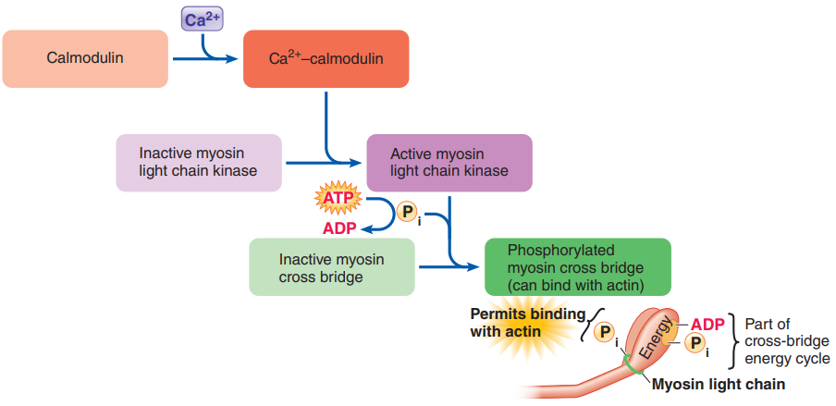**No troponin**: chemically alter myosin instead of physically altering actin
    - **Light chains**: light-weight chains of proteins attached to myosin heads
    - **Calmodulin**: intracellular protein structurally similar to troponin
    - **Myosin light chain kinase** (MLC kinase): phosphorylates light chain
* Uses ECF Ca much more – similar to cardiac, but **no T tube**
  + 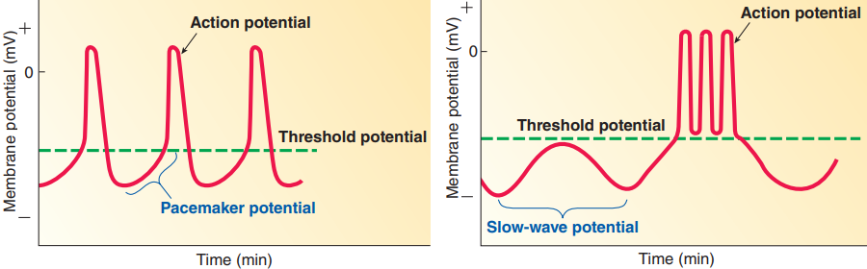Dihydropyridine receptors (Ca channel) in plasma membrane respond to AP
* **\*Pacemaker** vs **slow-wave** potential (for single-unit only)
* **\*Tone**: “resting”/baseline tension level (without AP still contracts partially)
* Gradationn through Ca concentration control
  + Nuerons not one to one, one neuron spread **varicosities** to many smooth muscles
* **\*Slow but ecomonical**, 3 specialties
  + Length tension relationship not strong, able to develop tension even when considerably stretched
  + **Stress relaxation response**: inherently relaxing when stretched
  + **latch phenomenon**: myosin attached for longer time, efficiently maintain tension

9.1 Blood Vessels

* 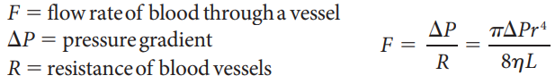**Flow rate**: volume of blood passing / time
  + Pressure gradient: start pressure – end pressure
  + Resistance:
    - Radius (surface area):
    - Length (surface area):
    - Viscosity of blood: , viscosity primarily determined by # of RBCs
* **Circulatory system**: end goal is capillary exchange
  + **Aorta => artery => arteriole => capillary => venule => vein => vena cava**
  + **Microcirculation**: arterioles, capillaries, and venules; within organs
* 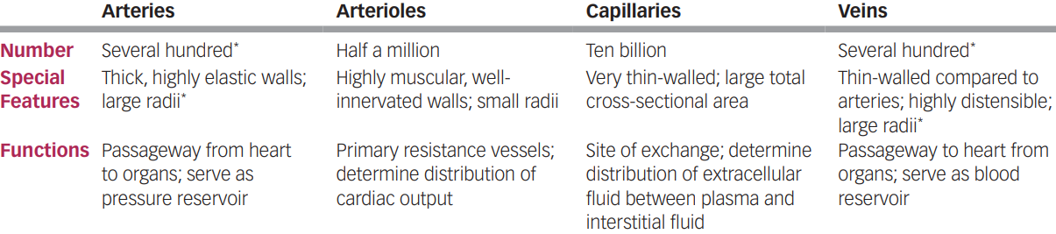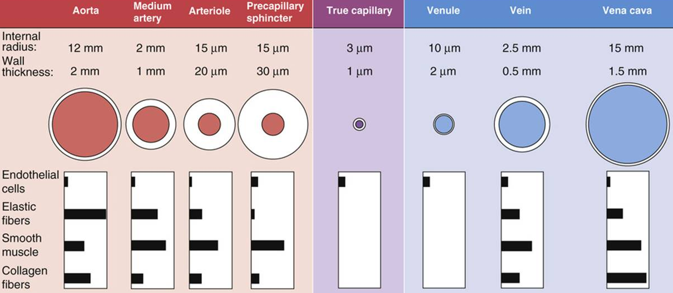Vessel: tunica adventitia (connective tissue) > external elastic lamina (elastic fibre) > tunica media (smooth muscle) > internal elastic lamina > tunica intima (endothelial)

9.2 Arteries

* Arteries have 2 main functions:
  + Rapid-transit: large radius => little resistance
  + **Pressure reservoir**: many elastic fibers (balloon like), provides driving force for blood when heart is relaxing
* **\*Blood pressure**: depends on distensibility (stretchability)
  + Systolic (max ~120 mmHg): only 1/3 blood entering arteries go to arterioles
  + Diastolic (min ~80 mmHg): no blood entering arteries but still leaving
  + Pulse pressure: pressure difference (why you fell pulse),
  + **Mean arterial pressure**: average pressure, in diastole,
  + 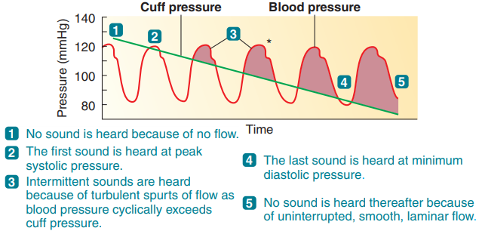**Sphygmomanometer**: detect pressure when Korotkoff sounds appear/disappear
  + higher resistance = more power loss = faster pressure drop
  + 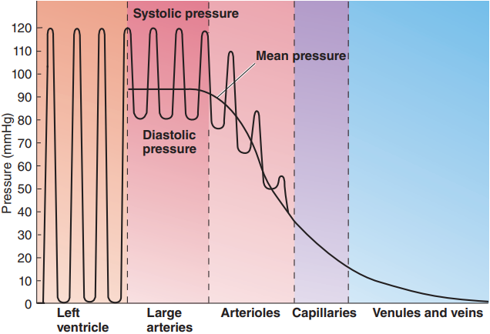**Pulsatile** from elasticity (stretching and recoiling)

9.3 Arterioles

* **Arterioles**:
  + \***Major resistance vessels** (much smaller radius)
    - Lowers pressure to maintain pressure gradient
    - Converts pulsatile pressure to **non-pulsatile** (not elastic)
  + \***Variable radius** (little elastic, thick smooth muscles)
    - Vary distribution of blood between organs (FR to brain no change)
    - 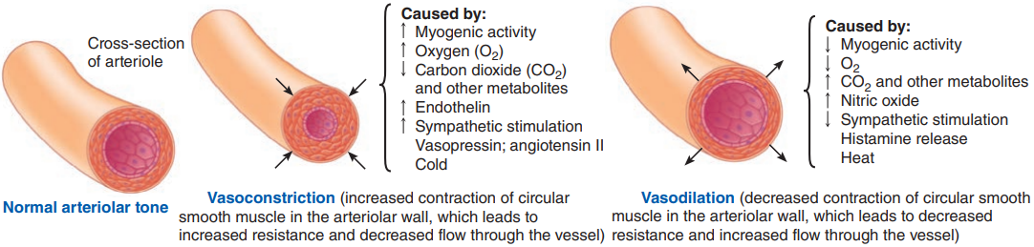Regulates arterial pressure
* **\*Vasoconstriction** and **vasodilation**: sympathetic NS, chemical changes, hormone
  + **Vascular tone**: baseline state of partial constriction
  + **Intrinsic** (local) control: chemical and physical
    - **Endothelial cells**: respond to chemical and physical changes, release local vasoactive mediators which act on smooth muscles
      * **Nitrate oxide** (NO): inhibit Ca, vasodilation
      * **Endothelin**: vasocontraction
      * Some are long term
      * Some triggers **angiogenesis** (new vessel growth)
    - Chemical triggers:
      * Local metabolic changes (alters local chemicals)
        + **Active hyperaemia**: dilation for cells metabolically active (acid (lactic, carbonic))
      * **Histamine** (not by endothelial) - vasodilation in injured area
    - Physical triggers:
      * Local change in **temperature** (clinical usage)
        + Heat – dilation, cold - contraction
      * **Shear**: friction of blood on endothelial cells => release NO
      * **Autoregulation** (Myogenic response): more blood => stretch => strength increase => contraction => less blood, vice versa
        + **Reactive hyperaemia**: dilation respond to blockage (chemical build up and no stretch)
  + **\*Extrinsic** (SNS) control: neural and hormonal
    - SNS **constrict** vessels except in brain (mostly local) for **pressure**
      * Has a baseline tone (decrease SNS is dilation)
      * Direct distribution of blood while maintaining pressure
        + Actual dilation (skeletal/cardiac) is local (**override SNS**)
    - **Cardiovascular control centre** (medulla, same as for heart)
    - Hormones:
      * 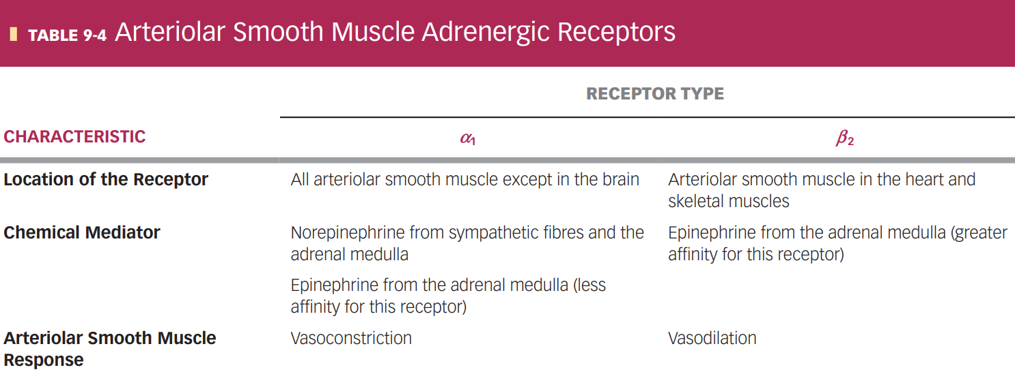**Epinephrine** (mostly ) & **norepinephrine** () reinforce SNS
      * Fluid control:
        + **Vasopressin** (ADH): maintain water balance by regulating urine formation (how much water kidney retain)
        + Angiotensin II: salt conservation during urine formation
        + Potent constrictors, essential in blood lose (need more water to increase plasma volume, constrict to maintain P)

Pulmonary Circulation

* Much **lower pressure** (lots of branching => high resistance)
* \***Constricts with low and high , dilates with high and low** 
  + Allows blood to be directed to oxygen filled lung segments
  + Can cause High Altitude Pulmonary Edema
* Fetal circulation: lungs collapsed, constricting mechanism help bypass lung

9.5 Veins (contribution to blood pressure)

* \***Veins**: **blood reservoir** / capacitance vessels, **volume control**
  + large radius, little resistance, low pressure
  + highly distensible with little elastic recoil (little elastic, many collagen)
* Venous capacitance: blood in veins
* \***Venous return**: blood entering each atrium per minute, 1/capacitance, 5 factors
  + **Vasoconstriction** (SNS): increase return => increase flow (opposite from artery)
  + Blood volume: more blood = more return
  + Skeletal muscle pump: muscle contraction constricts veins, counter gravity
  + Venous valves: around muscles in veins, prevent backflow & counter gravity
    - Varicose veins: incompetent valves, blood pool in veins
  + Respiratory pump: lowered chest pressure from breathing enhance return
  + Cardiac suction: ventricular contraction lower atrial pressure (+ return)

9.6 Blood Pressure

* 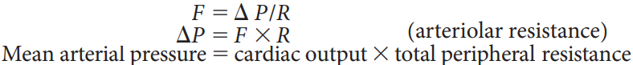*The blood pressure monitored and regulated in the body is **mean arterial pressure**
  + must be high enough to ensure sufficient driving pressure
  + must not be so high to creates extra work for the heart and increases the risk of vascular damage / rupture of small blood vessels
  + 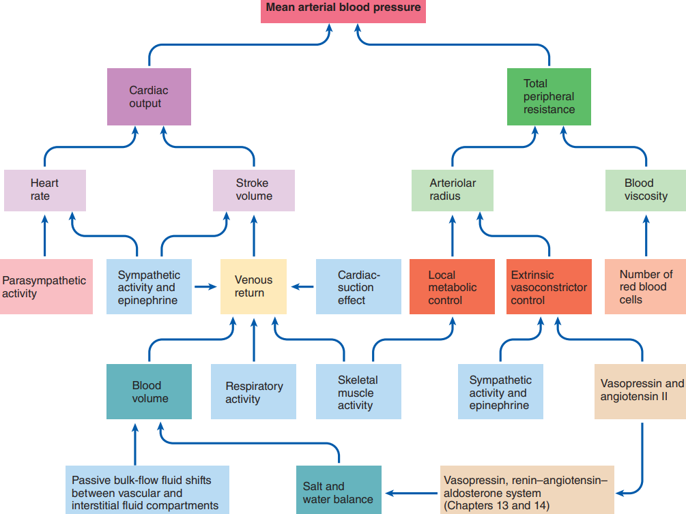Short term (constrict vessels) vs long term (increase fluid, viscosity)
* \***Baroreceptor reflex**: blood pressure regulation
  + Receptors: **carotid sinus** (on vessels to brain) and **aortic arch** (at start of aorta) baroreceptors detects mean arterial pressure and pulse pressure
    - Frequency of firing AP BP
  + Integrating centre: **cardiovascular control centre** (medulla)
    - Controls ratio between SNS and PNS
    - **Negative feedback**
* Other reflexes and responses:
  + Left atrial volume receptors: water and salt balance
  + Chemoreceptors (oxygen in arteries): increase respiratory activity & BP
  + Fight or flight: increase HR and BP
  + Exercising: increase HR, CO, BP; mostly constrict, dilate in skeletal muscles
  + Temperature regulation: dilation to eliminate heat
* **\*Hypotension** (low BP, high BP is hypertension)
  + **Orthostatic hypotension**: insufficient compensatory response to gravity shift
    - Stand up => gravity => pool in veins / low return => low SV, CO, BP
    - Prolonged bed rest: reduced baroreceptor reflex, low blood volume => BP too low, dizziness / faint
  + **Circulatory shock**: BP too low, inadequate flow; 4 types
    - Hypovolemic (low-volume) shock: low blood volume (bleed/dehydration)
    - Cardiogenic (heart-produced) shock: heart too weak
    - Vasogenic (vessel-produced) shock: widespread dilation
      * Septic shock: dilation caused by infections (release chemicals)
      * Anaphylactic shock: dilation caused by histamine
    - 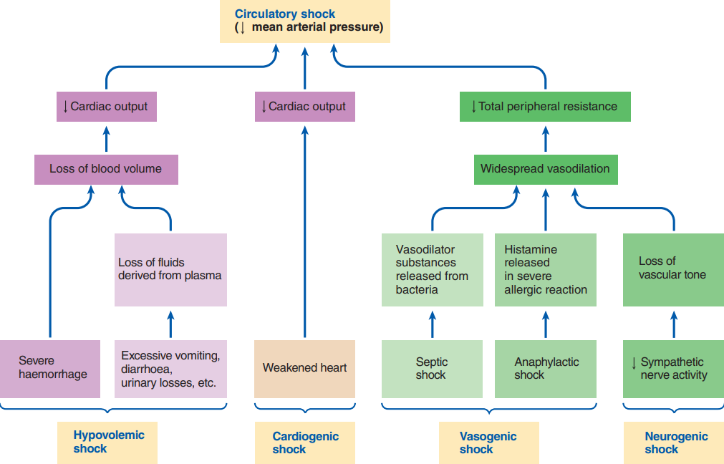Neurogenic (nerve-produced) shock: SNS problem (deep pain can cause)

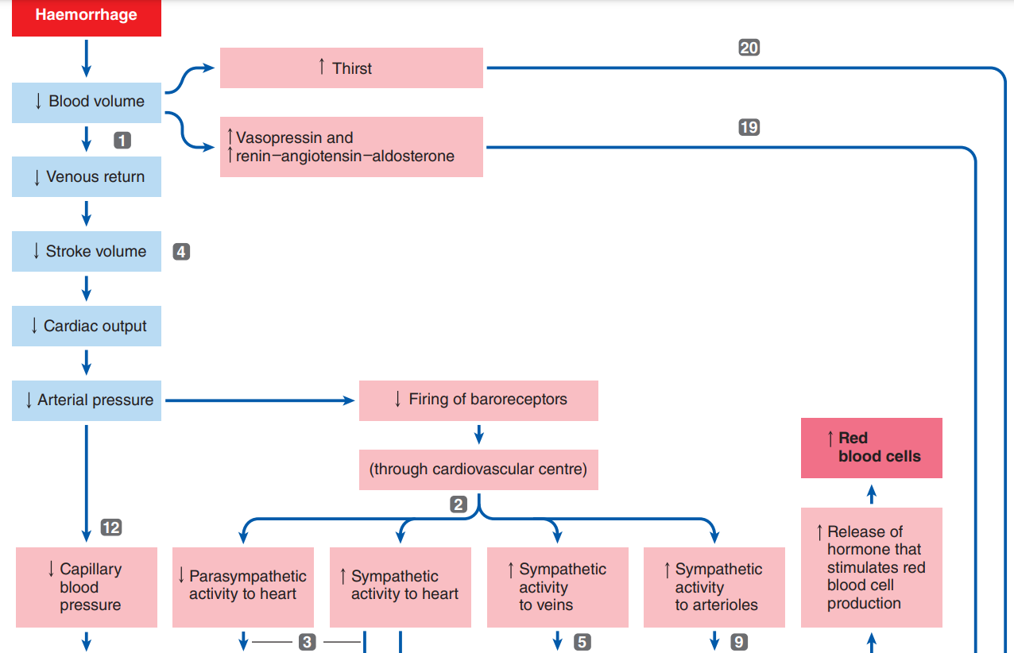

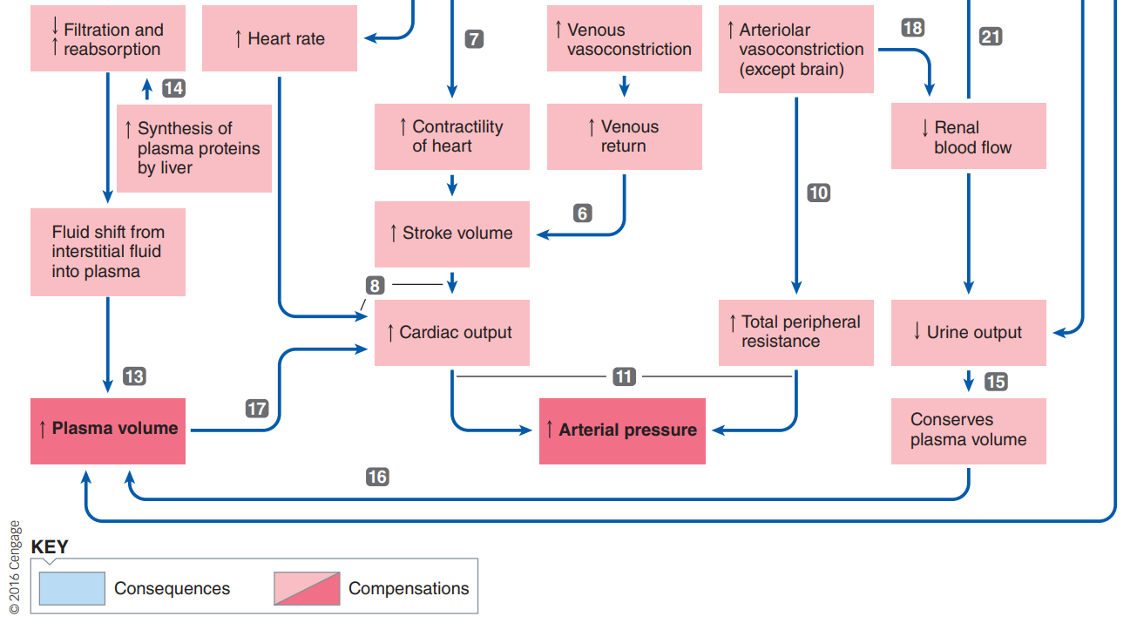

* Ex: haemorrhage
  + **Baroreceptor reflex** – SNS response – increase CO & R – increase BP
  + **Autotransfusion**: low BP cause some interstitial fluid to flow into capillaries
  + **Fluid** **control**– reduced urinary output – increases thirst – water salt balance
  + RBC reproduction